**Project 1: ELB**

Created two Linux instances-

* Linux Server 1 with public IP- 3.17.134.150

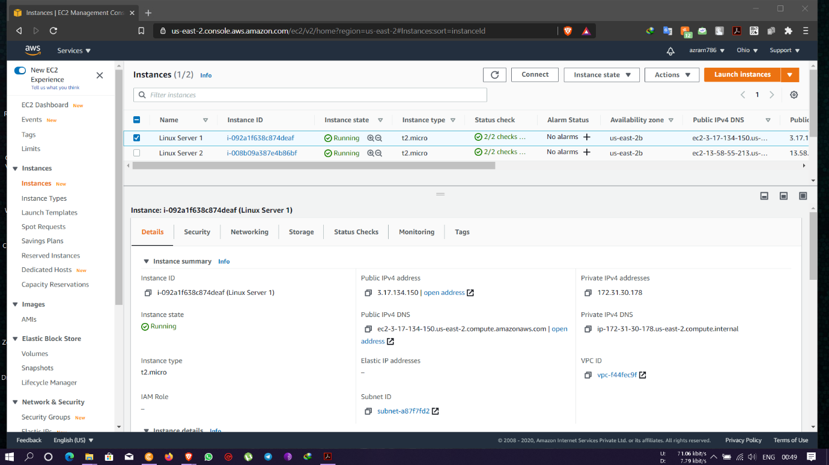

* Linux Server 2 with public IP- 13.58.55.213

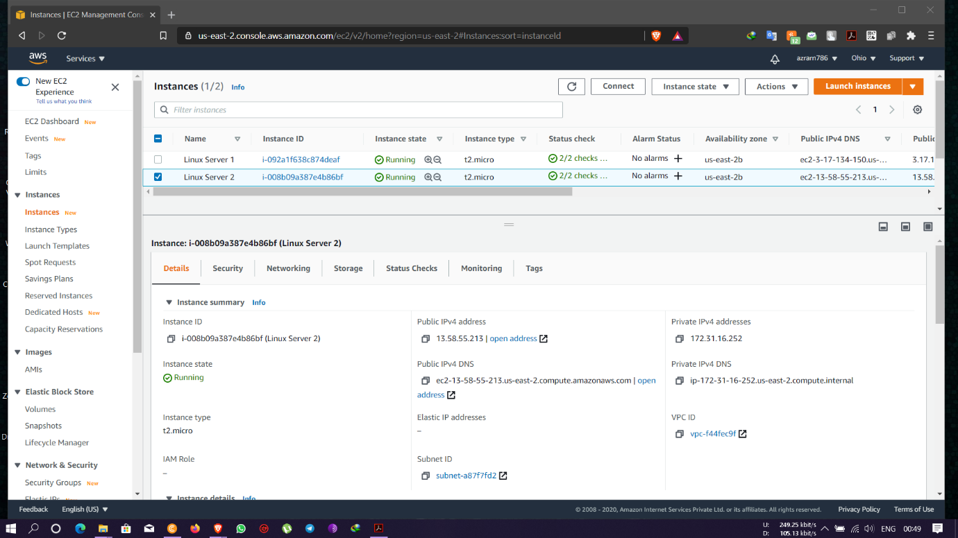

* Active running screen of Linux Server 1

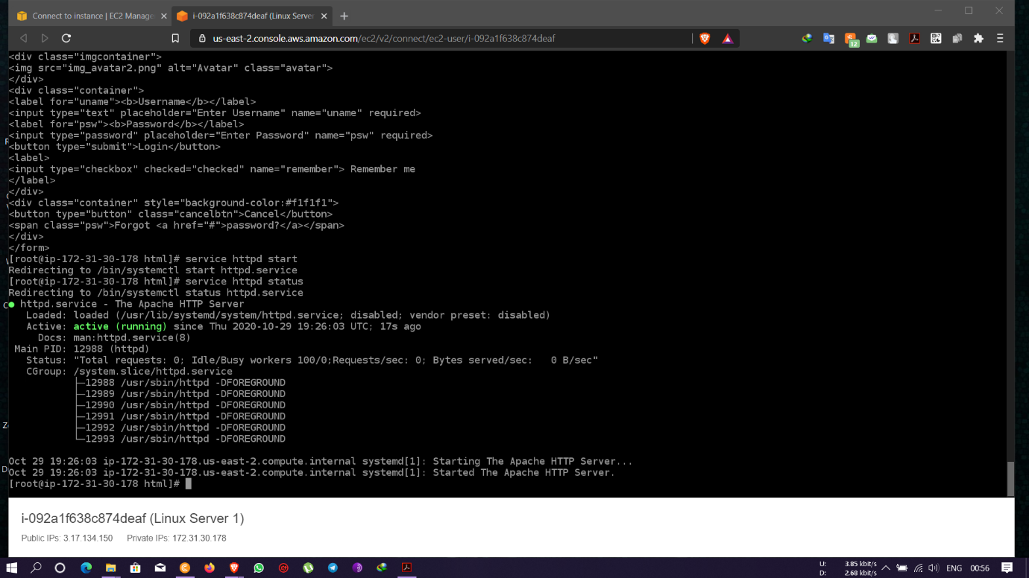

* Active running screen of Linux Server 2

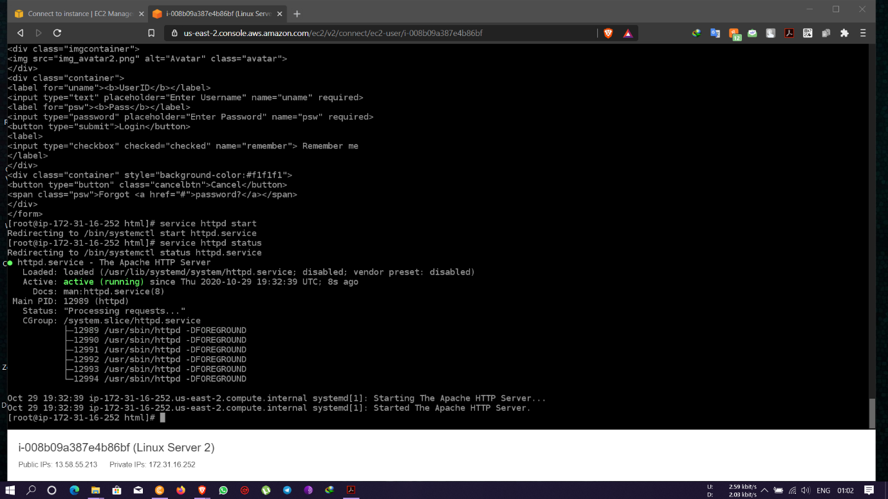

* Login page of Linux Server 1 with username and password on Public IP- 3.17.134.150

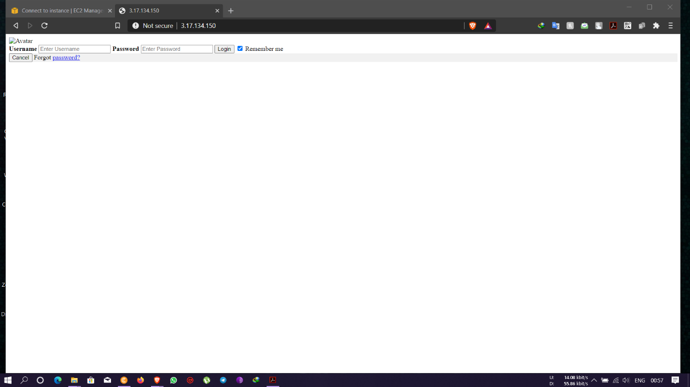

* Login page of Linux Server 2 with UserID and Pass on Public IP- 13.58.55.213

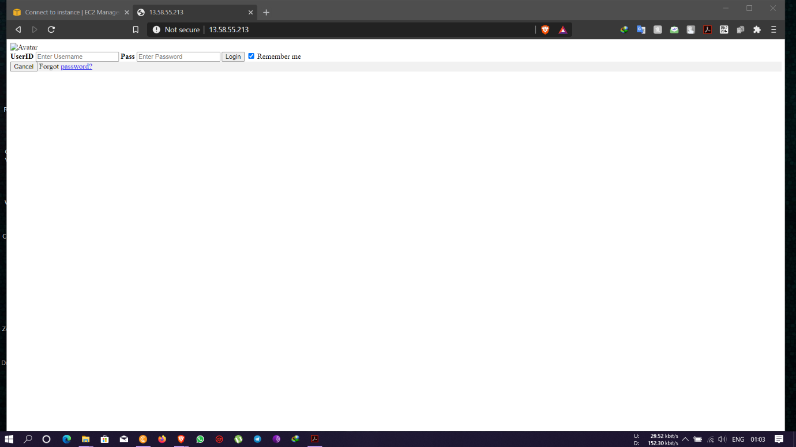

* Create an application Load balancer (ELB) with the above two instances as targets with name demoELB

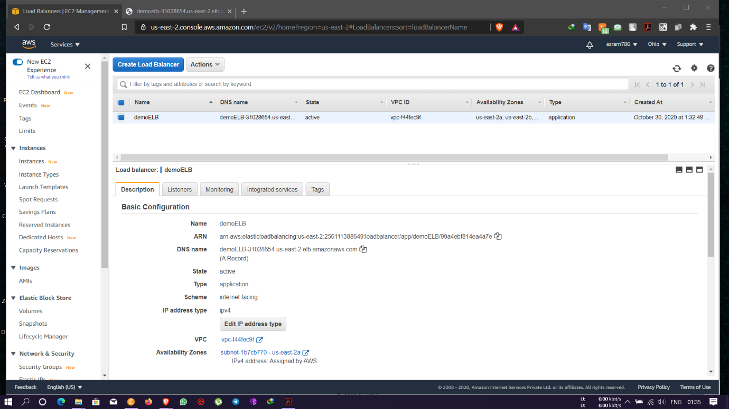

* Checking the functioning of ELB using the DNS of the ELB with reply from Linux Server 1

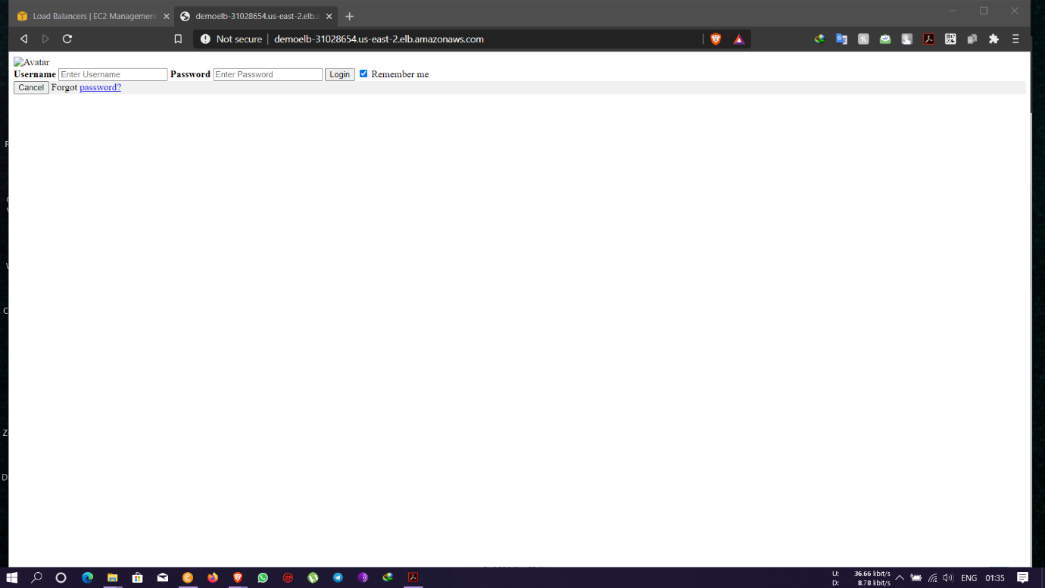

* Checking the functioning of ELB using the DNS of the ELB with reply from Linux Server 2

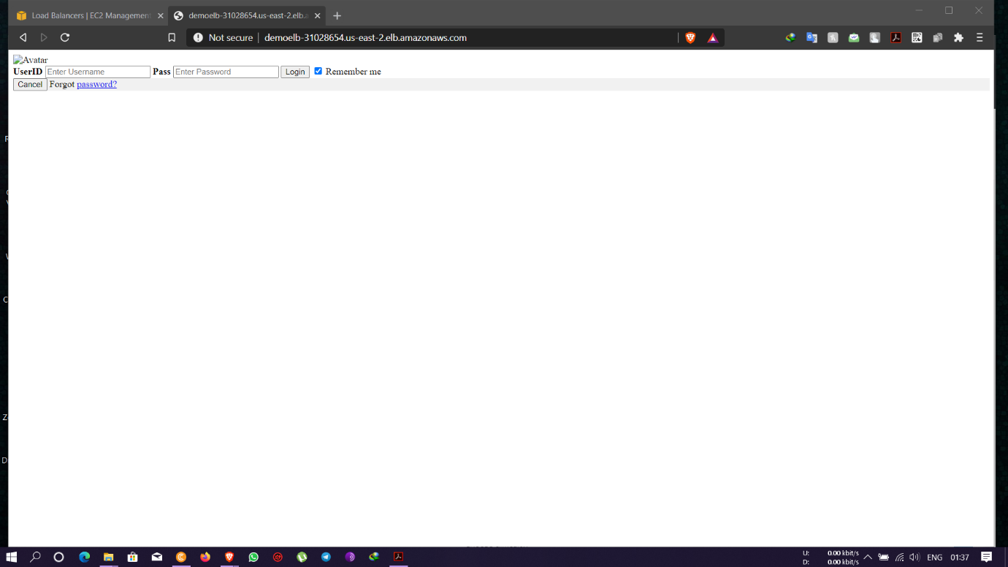

**Project 2: AWS Cognito**

Creating a User Pool- Name and Attributes

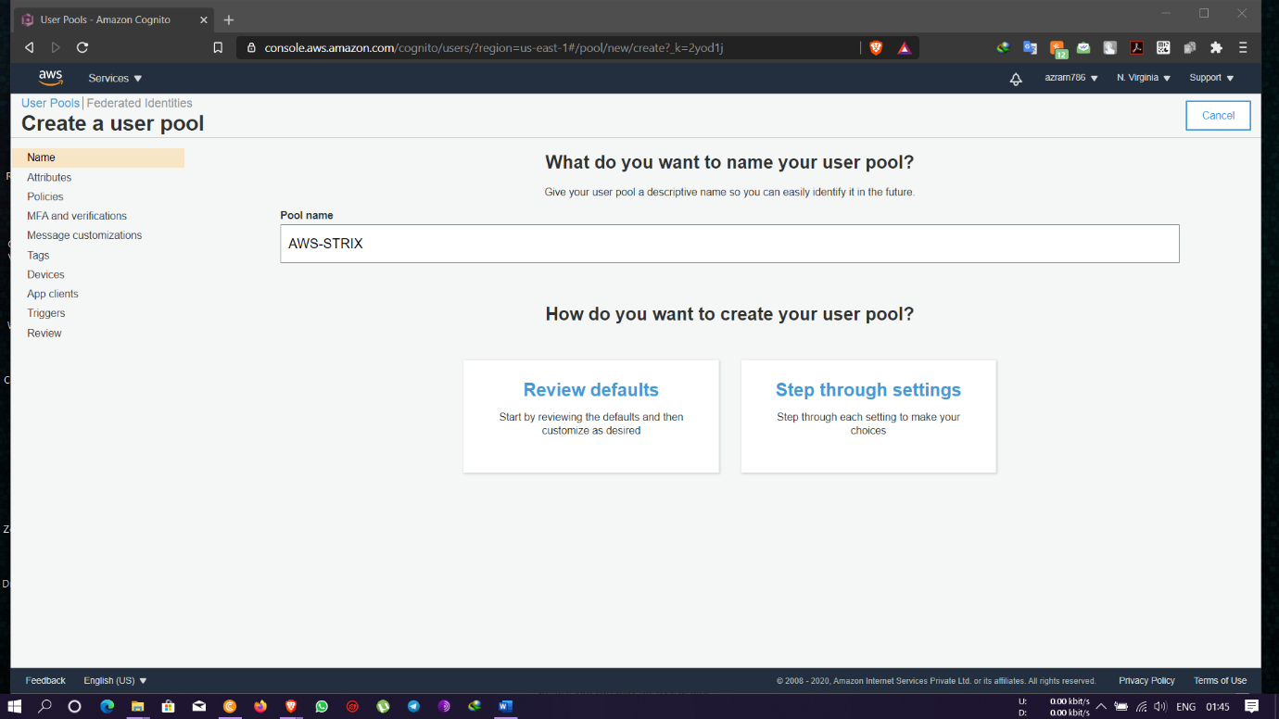

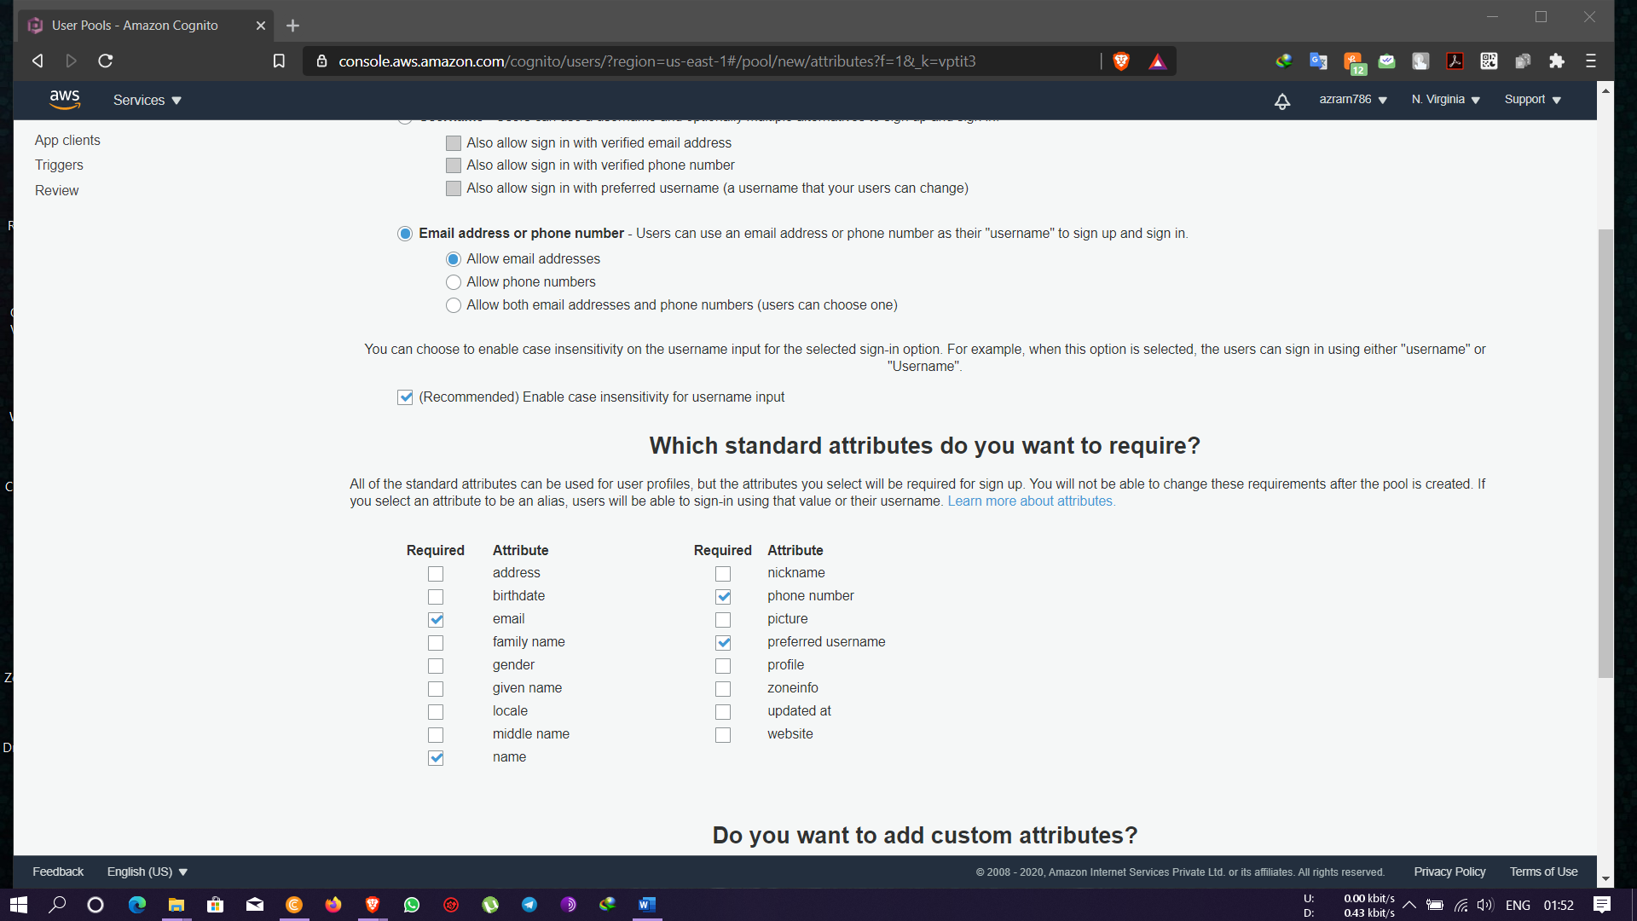

* Policies

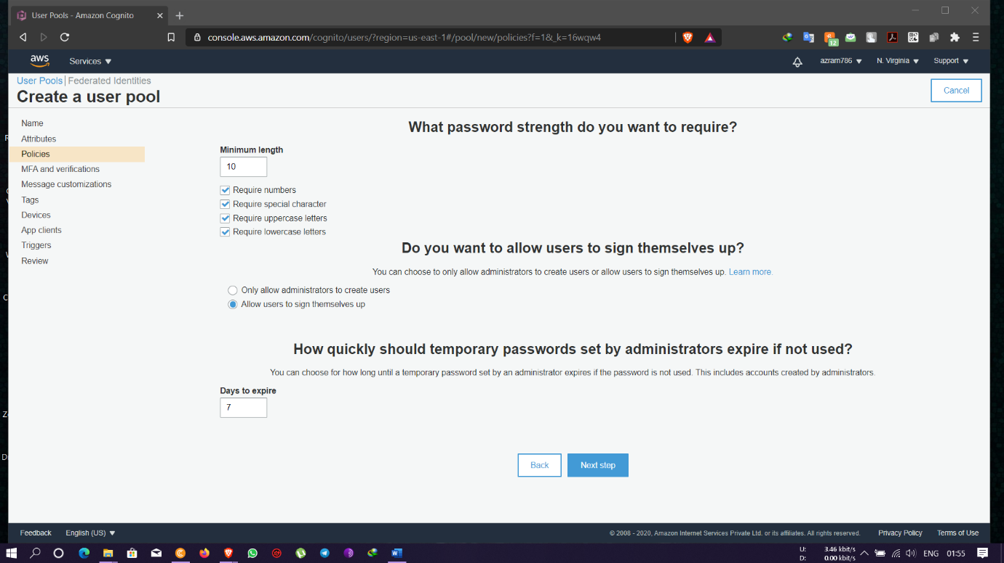

* MFA and Verifications

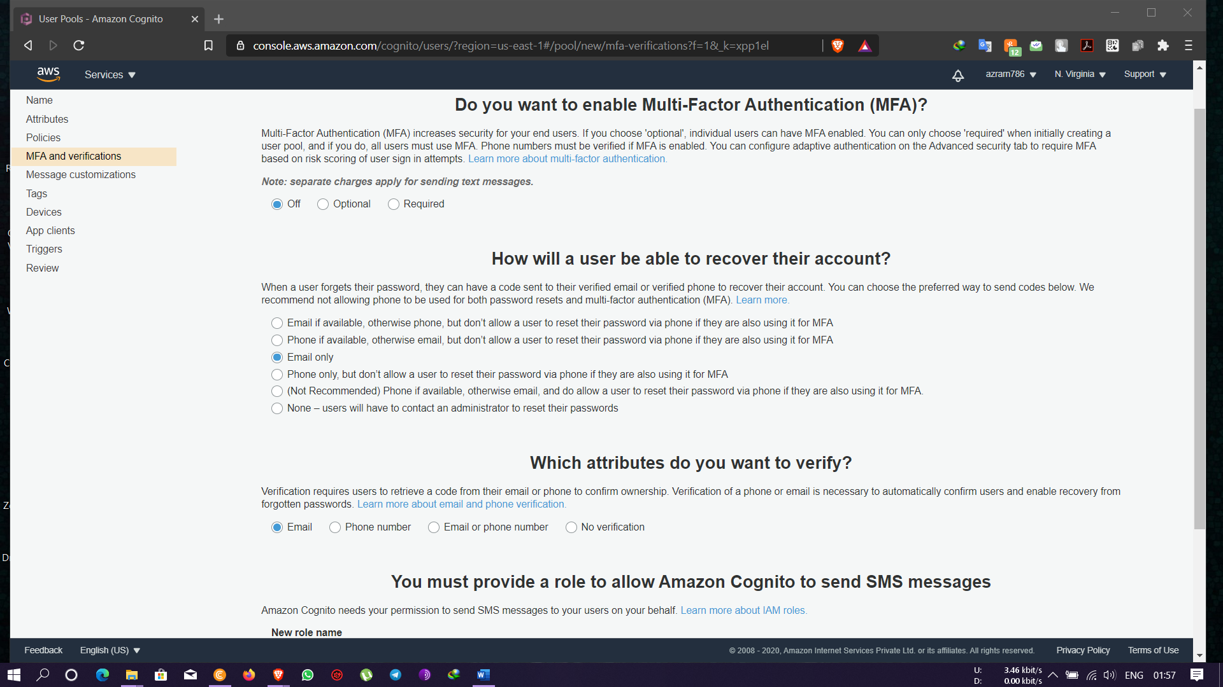

* Message Customizations

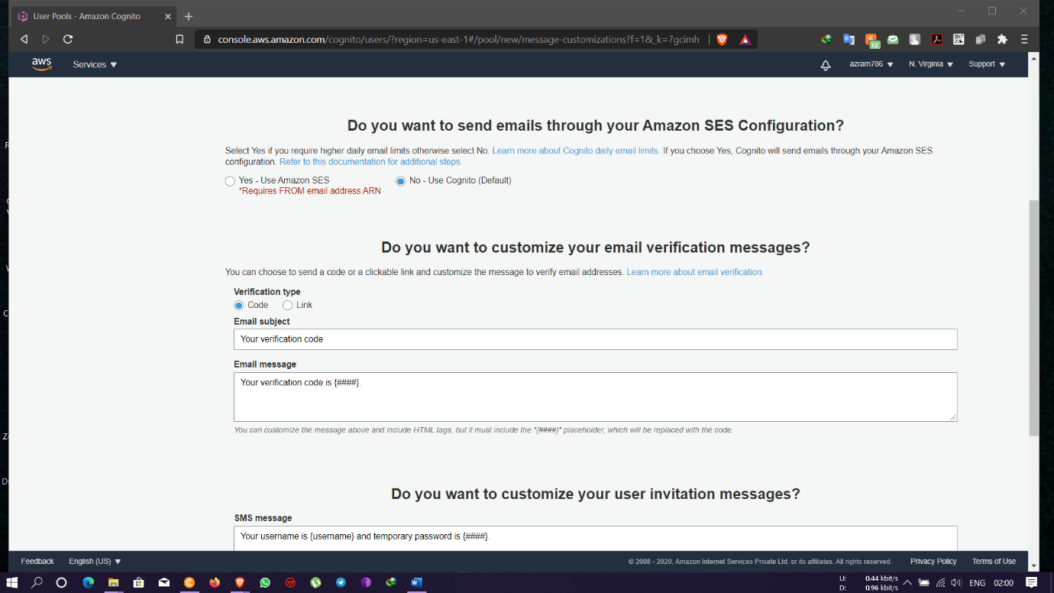

* Tags- where we add a tag key and tag values

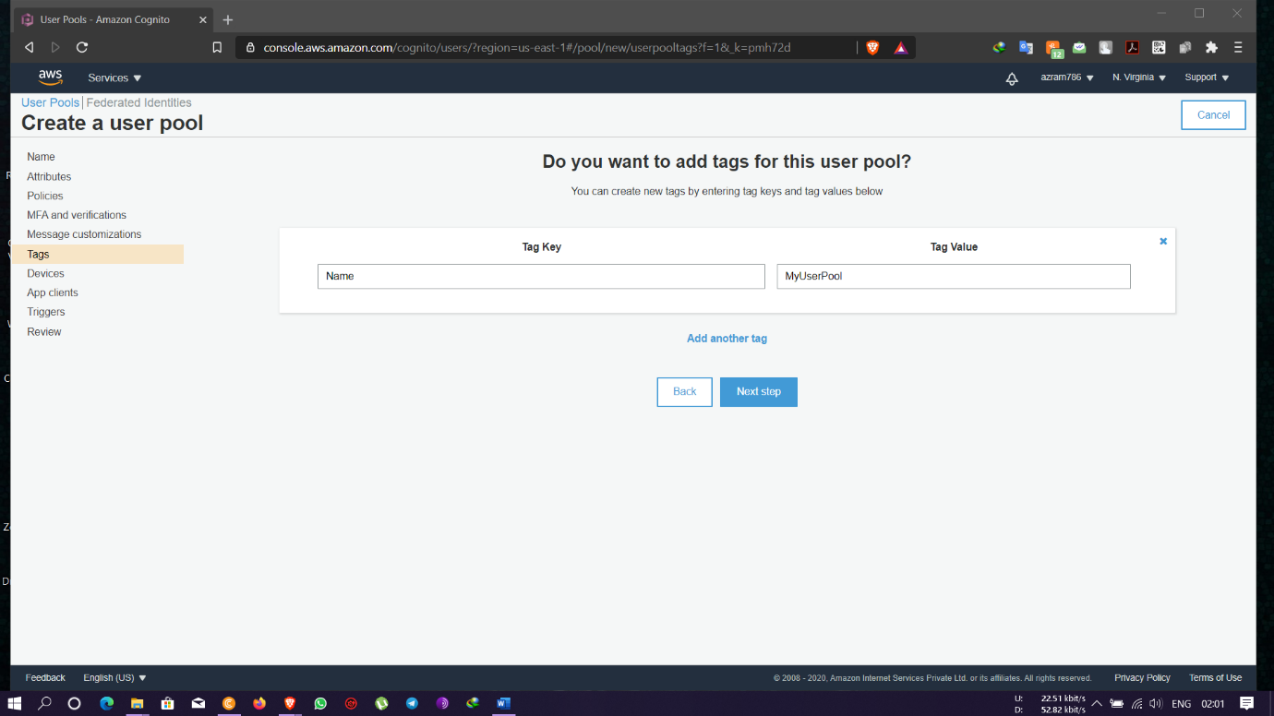

* Devices- for opting to remembering a user’s device

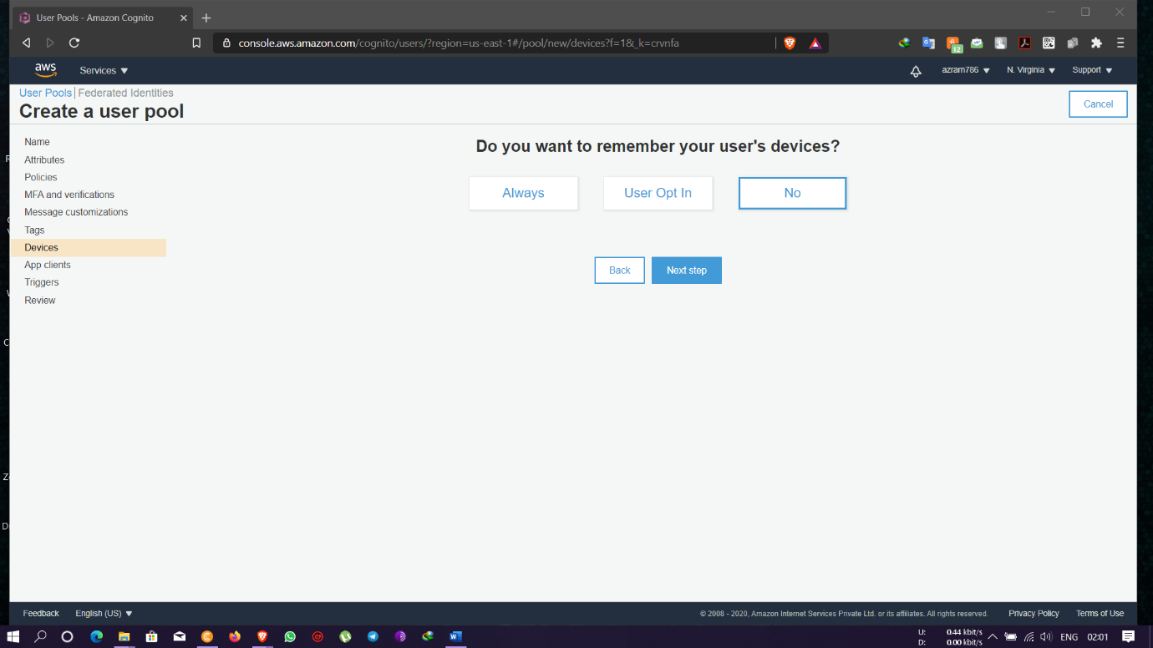

* Customize workflows to trigger with different events

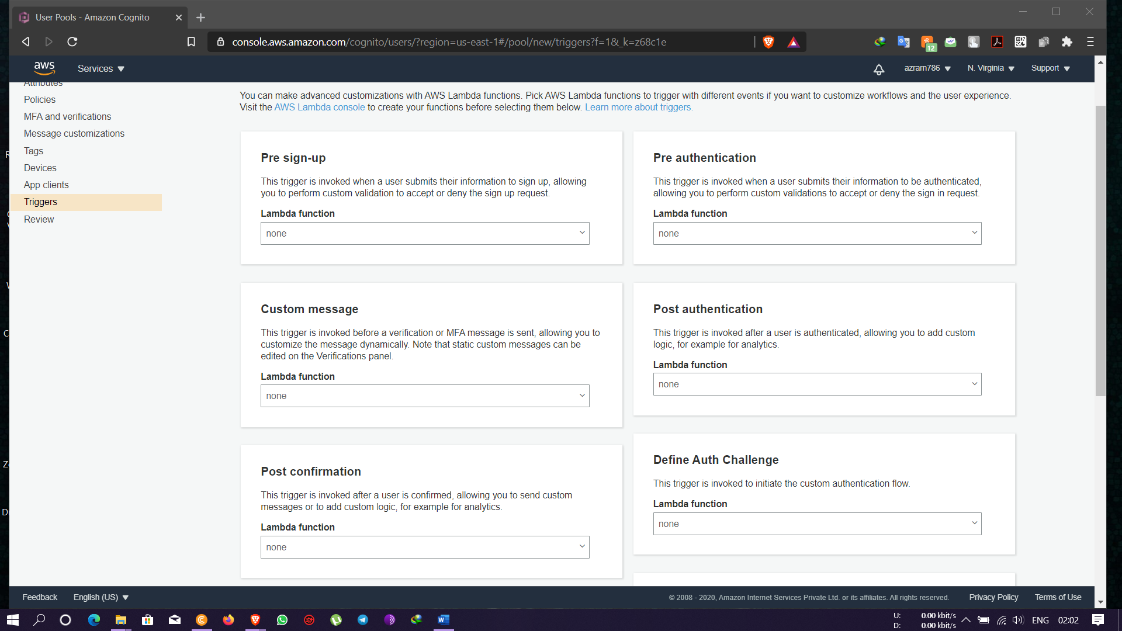

* Reviewing all the settings and Creating a User Pool

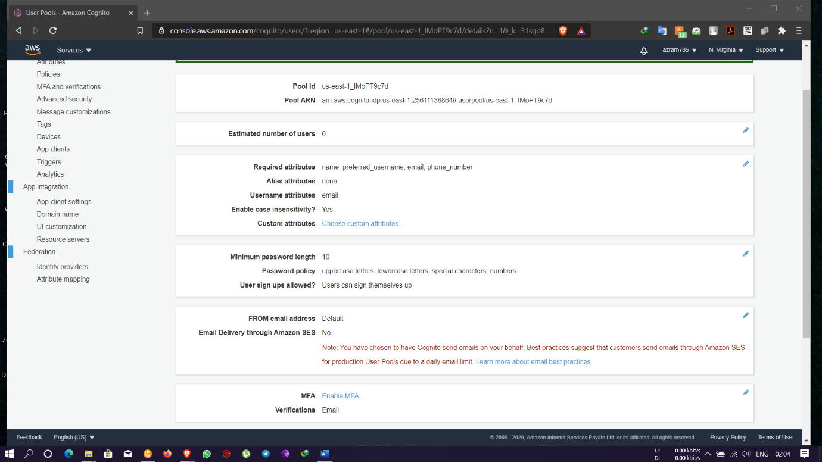

* After successful pool creation then creating users and groups as required

